LSTM – Long Short Term Memory

Word-by-word input seq and output seq
Slow to train

Not truly bidirectional:
It learns the context left-to-right and right-to-left separately and then concatenates them.
The true context is slightly lost.

Transformers:

Fast to learn
Deeply bidirectional

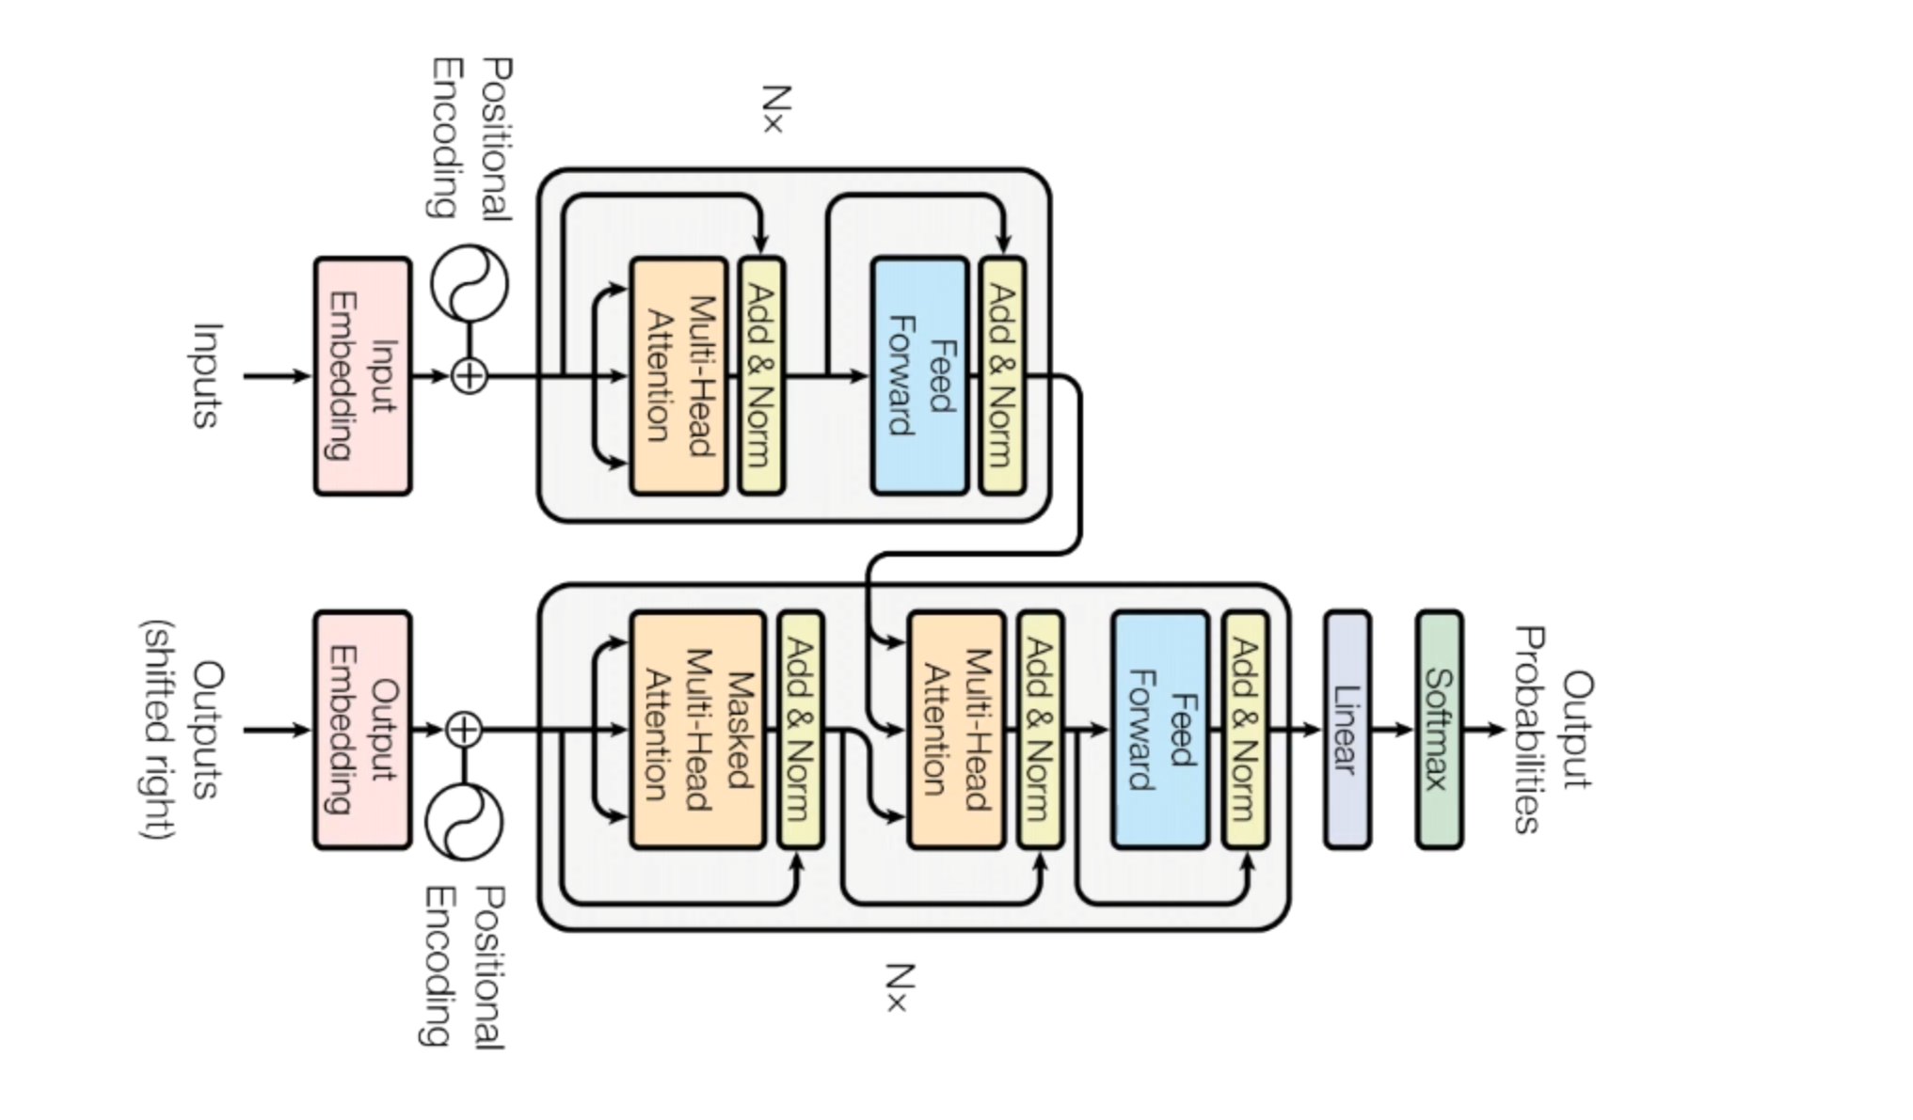
The transformers contains two components:
- Encoders
- Decoders

The encoder takes a sequence of English words as input simultaneously and it generates embeddings for these words simultaneously.
These embeddings encapsulate the meanings of the sequence of words

The decoder takes these embeddings along with previously generated words to generate the next word.
It does this one word at a time until the end of sentence is reached.

A stack of decoders gives the GPT architecture
A stack of encoders is what gives the BERT architecture

BERT (Bidirectional Encoder Representations from Transformers):

It basically needs to understand natural language.

First pretrain the BERT to understand natural language.
Then fine tune BERT to learn specific task.

PreTraining (Pass 1):

Goal - What is language ? What is context ?

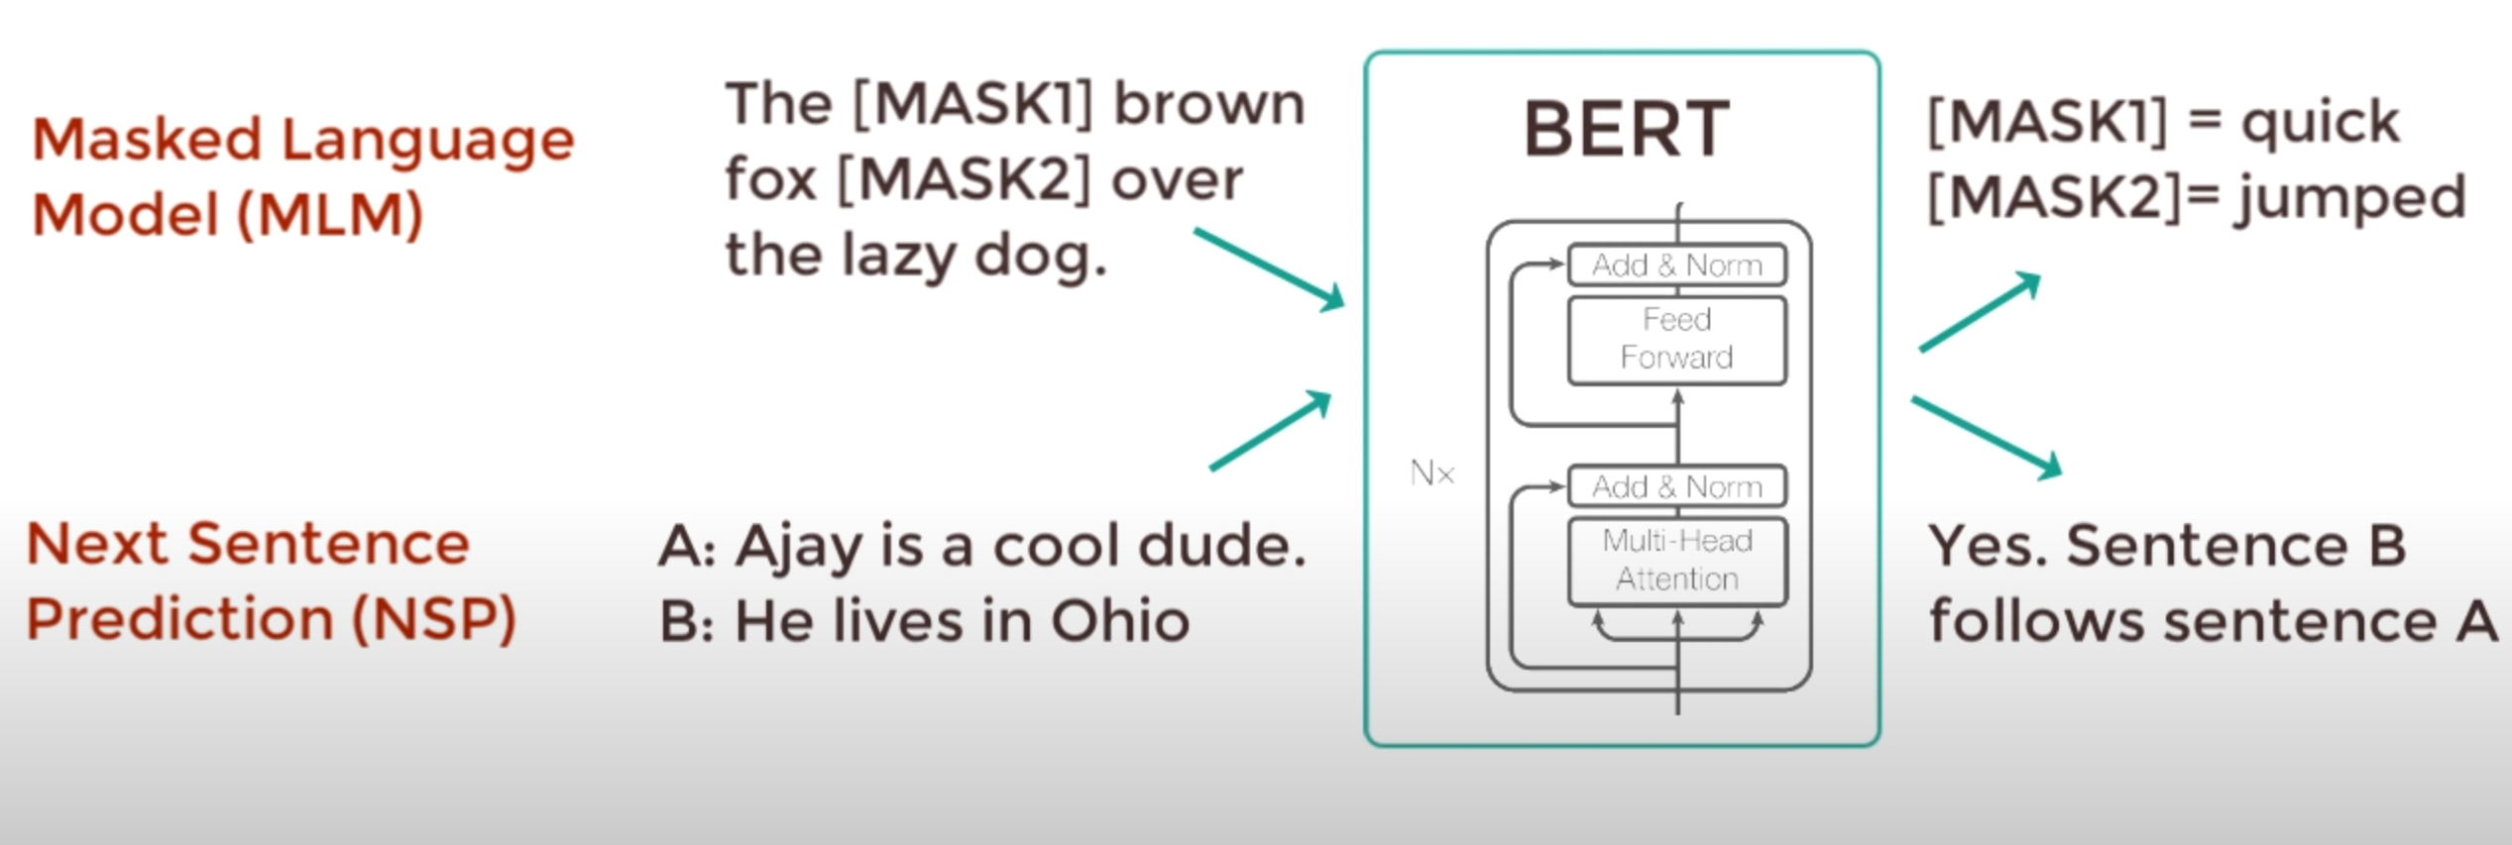

Fine Tuning (Pass 1):

Goal – How to use language for a specific task ?

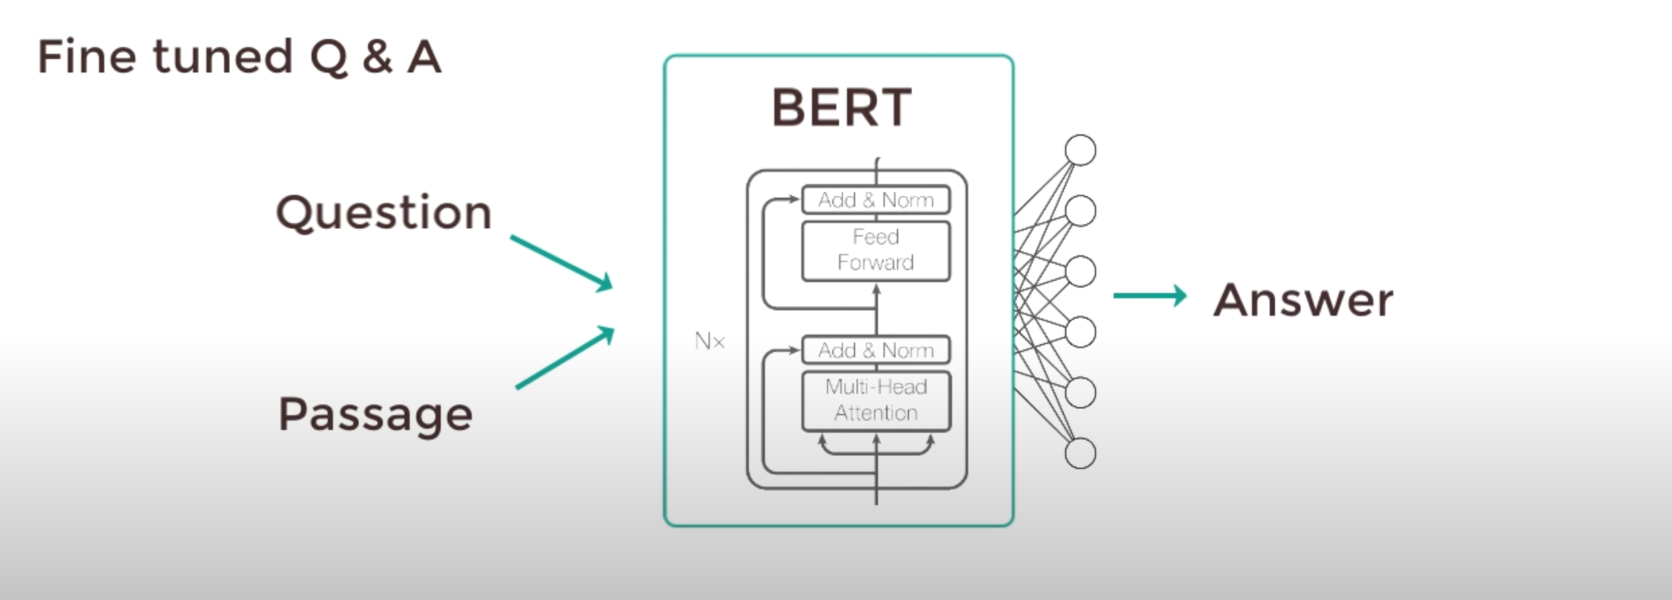

Here only the output parameters are learned from scratch. The remaining model parameters are slightly fine-tuned, therefore, training is fast.

For an NLP problem, replace the output layers and train it with a specific dataset.

